Welcome to the National Festival of Youth Theatres at Kilkenny College – 2024
When you come with your youth theatre to the National Festival of Youth Theatres, this is what you can expect to find when you arrive. This is a Visual Story of what you can expect to see and do.

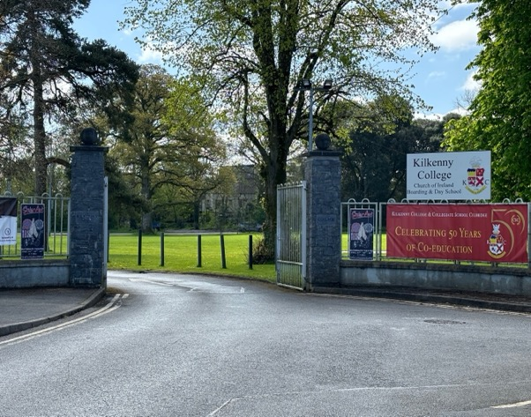
Main Entrance to Kilkenny College.

Your Bus or car will drive up to through these gates. This is the Main Entrance to Kilkenny College.

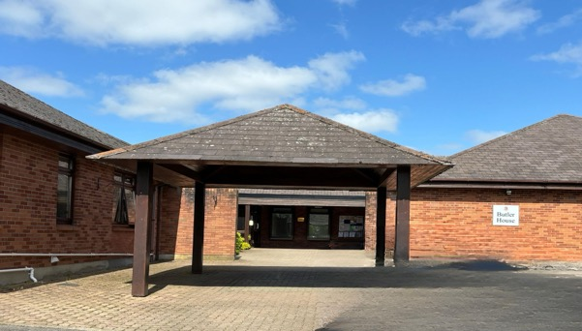
Your Bus or Car will Pull Up beside this Building. It is called Butler House. You will enter under this ARCHWAY and through the doors on your LEFT into this space
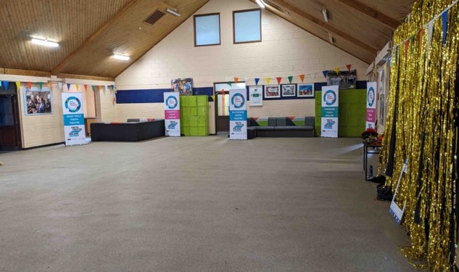
This space is called the BOYS STUDY HALL. You will be in this room a lot over the week. When you arrive, you will probably have to wait here for a few minutes. This room sometimes gets very loud and noisy, especially when there is a lot of people in in. You can put in ear plugs or use your ear defenders here. We will be using this room as a social space and for some activities in the evening. The lights are bright in here. Some can be turned down. There will be different coloured lights here too. They are not on in this picture. There will be bean bags you can sit on.

Boys Study Hall

.
You will meet some of the members of the YOUTH THEATRE IRELAND TEAM. These are the organisers of the festival and are here to help you. Here are their name and pictures and some fun facts about them.

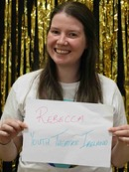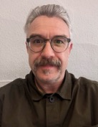
Rebecca Feeley
Loves to bake
Cathal Thornton is a Magician
Eoghan Doyle
WWE Wrestling Fan
Alan King
Loves Quizzes

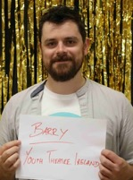
Betty Duffy has watched
every single Marvel Movie
Katie Meehan Was a dancer
Barry Morgan
Plays Guitar
Dave Kelly
Loves to Run

Soon after your arrival, you will have the chance to drop your bag in your DORM ROOMS. You bed rooms are for sleeping in. Your leaders will tell you what time bed time is and what time you get up and ready for breakfast each day. If you are tired before bedtime you can go to bed earlier. Just tell your leader.

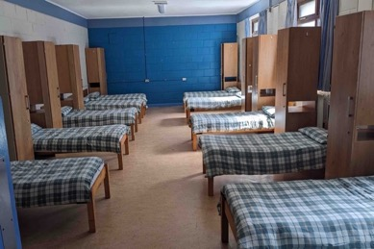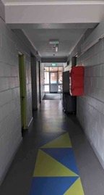
Typical DORM ROOM
Dorm Room
Hallways
Your room will look a bit like this one. Some rooms will have between 8 – 12 beds. Other rooms may be smaller with 4 or 6 beds. You will be sharing a room with some of your youth theatre friends and maybe other young people of the same gender from another youth theatre. You can choose any bed that hasn’t already been taken. You will have a locker to hang up your clothes and space under your bed to store your bag.

No one is allowed eat snacks or drink in the bedrooms. You can only do this in the Snack Room or outside.

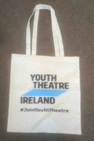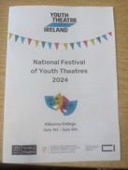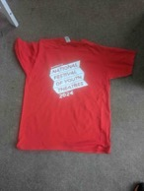
If you find clothes labels irritate you, you can cut the label of your t-shirt. Ask your leader for help to find a scissors and cut it off for you if you need that.
You will all get a Tote Bag with some goodies, an NFYT 2024 Programme and a RED NFYT T-shirt. You can use this programme to check where you should go you’re your workshops, activities, and meals. Take a photograph of the timetable on the inside so you can find it easily on your phone.
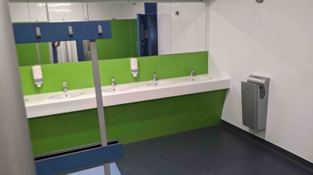
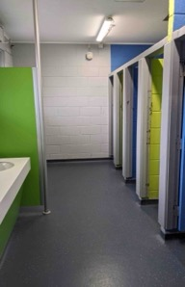
Hand Dryer
Toilets

There are Toilets and Showers close to your Dorm Rooms. They are separated and will be clearly marked for you. The toilets have sinks and cubicles. There are urinals in the male toilets

Don’t forget to turn off taps after use. There are hand dryers on the walls to dry your hands. Please don’t use these during the middle of the night as you might wake people up. Use your towel instead to dry your hands after washing.

There are separate Showers. These will be clearly labelled in separate rooms. The showers have individual cubicles with curtains for your privacy. Wear a bathrobe or clothes when going into the shower room. Bring your own shower gel or soap. You may not want to shower everyday, but you will get sweaty from all the workshops, so make sure you wash yourself at least once everyday. If you need more privacy please let your leader know.

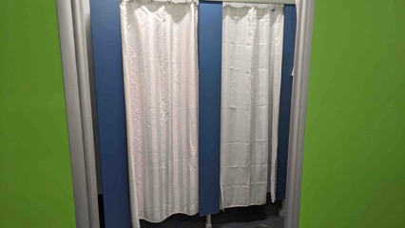
Showers

Everyone will meet back in the BOYS STUDY HALL before your first workshop. Before you head off from there you will meet your Assistant Workshop Facilitator. Each coloured workshop group will have one person assigned to that group for the week. They will bring you over to your workshop room each day.
If you have any problems or issues during your workshops please talk to your Workshop Assistant Facilitators. They are there to help you.

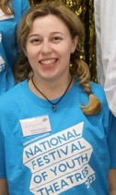
Róisín - Red Group Róisín enjoys baking and is a huge Swiftie.
Nuala - Green Group
Nuala Loves climbing trees, photography and traveling.
Orson - Purple Group I am a circus performer and a clown and I have my own kids theatre show called “the adventures of the exotic Dr Proctor.

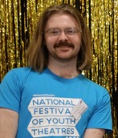

Cian - Blue Group
Cian loves discovering new music and chatting about album recommendations.

Raquel Yellow Group
Loves Mondays.

Group Workshops
One of the first activities you will do is a Group Workshop. You will be in a workshop with a lot of new people and one or two people from your own youth theatre. Music Mania will take place in the Music Room. All other workshops building called the Swift Building. They are right beside each other.
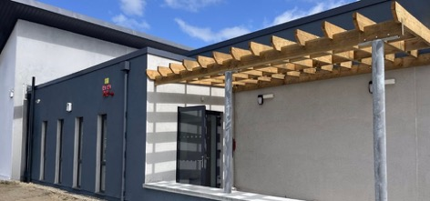
Music Room Entrance

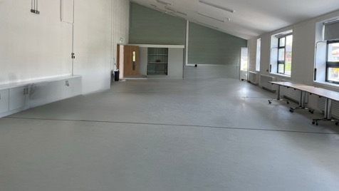
Workshop Space in Music Room

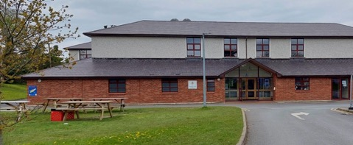
The SWIFT BUILDING Entrance

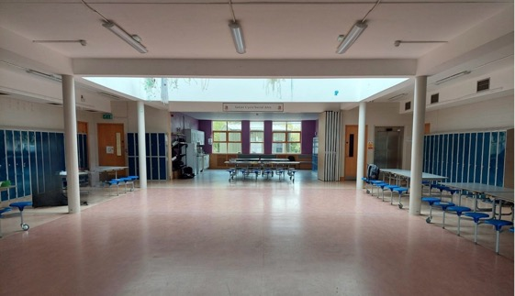
Lobby/ Workshop Space in Swift Building

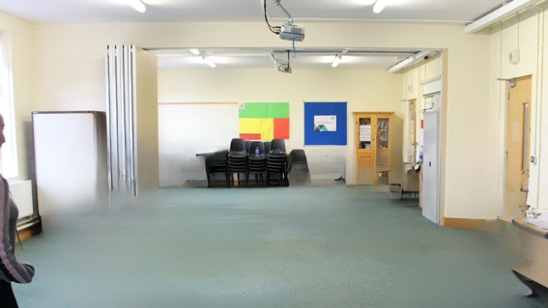
Workshop Space in Swift Building

These are the Facilitators you will be working with for the week as Part of your CORE WORKSHOP GROUPS

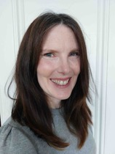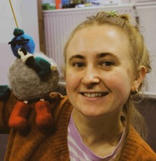
Ciara -– Blue
Play Explores
Swift Building
Downstairs Right
Ciara has a dog called Bosco
and I love to listen to podcasts while we go for walks, especially by the sea.

Oonagh – Purple
Having Your Own Back
Swift Building
Upstairs
When I was 7 years old I fell off my bike onto the spikes on railings. I had to have 14 stitches. 7 on the inside 7 on the outside!!

Jo– Red
Puppetry and Object Play
Swift Building
Downstairs Left


Nick – Yellow
Streets Ahead
Swift Lobby - Nick loves taking things apart to see how they work, especially old bicycles!
Ciara & Riain – Green-
Musical Mania
Music Room 1 Ciara One of the first shows I ever saw on the West End was Wicked and I am very excited for the new movie adaptation!!
Riain loves to sing

Dining Hall

Once you are finished your workshop it’s Dinner Time. Your Workshop Assistant Facilitator will bring your over to the Dining Hall on the first day.
All your meals; Breakfast, Lunch and Dinner will be served in the Dining Hall.

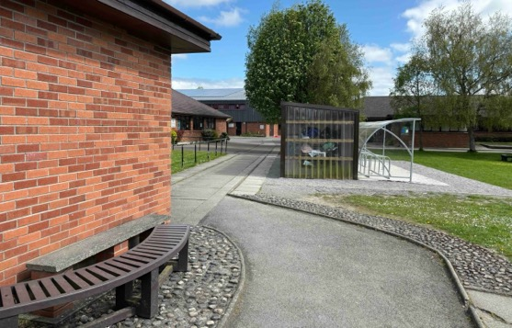
Pathway from Boys Study Hall to Dining Hall
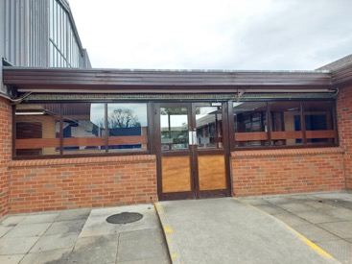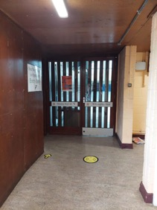
Entrance to Dining Hall from Boys Study Hall

You will see Yellow Arrows on the floor showing you which way to go. Go up the stairs , across the hallway and then you are in the DINING HALL

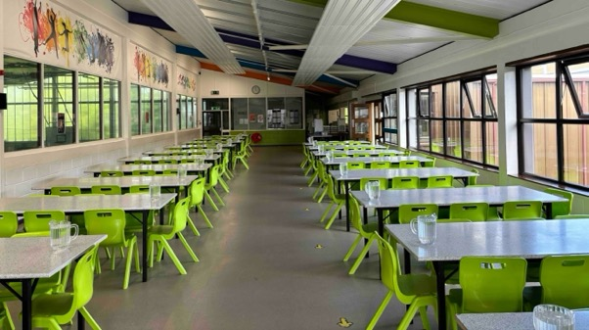
Queue up alongside this wall
This is the DINING HALL. You must queue up along the Left Hand Side Wall until you come to the Serving area. We get in line and we wait until it’s you turn to get your meal.
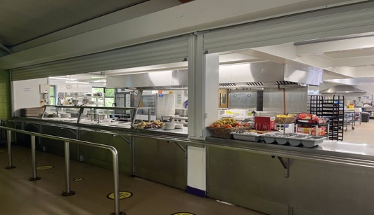
Take your cutlery from here
Serving Area in Dining Hall
Take your tray from here
At the Serving Area the Canteen Staff will ask you want would you like for your meal. They will be two choices for lunch and dinner. For breakfast you take some cereal and bread to make toast if you want. If you cannot eat certain foods we will let the canteen staff know. Please tell them if you cannot eat certain food as they might forget. If you need to know what is on the menu in advance, ask your leader to send you on a picture of the menu. They will be able to do this from 12pm

Your youth theatre will be given either the early or later meal time. This means you will go for your meals at the same time every day. Meal times are a great opportunity to meet you own youth theatre members and leaders and catch up and chat over your meal. Check on your Timetable for your Meal Times. They will be the same every day.
When you are finished your meal, please tidy up after yourself. Return your empty plates, cutlery and any other rubbish and place it on the TRAY RACKS at the End of the DINING HALL

Be careful around the toaster. It can get very hot. A member of the Youth Theatre Ireland Team will be at the toaster if you need help.

Social Spaces

In the evening and during breaks you can hang out in The Snack Room and The Games Room, the Pool Table Room and the Craft Room. Look for these Signs

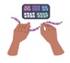
Snack
Room
Pool Table
Room
Quiet
Room
Craft
Room
Game Room

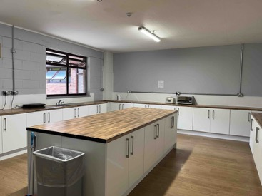
In the Snack Room, you can make
tea and toast, pot noodles or bring your own snacks. Please make sure to clean up after yourself, including washing your crockery and cutlery and putting your food away in the cupboards.
Snack Room
Use the waste Bin
If you find you are overwhelmed or just need a break away from everything you can go to the Quiet Room to decompress or regulate yourself. Just tell your leader where you are going. Bring any stim toys, ear defenders or anything else you need.


The Shop

There is Circle K Service Station across the road from the College to buy sweets and other treats. Please do not go to the shop on your own, you must be accompanied by one of your leaders. Make sure to bring cash or your card to pay.

Head out the Main Gate and go up the laneway.

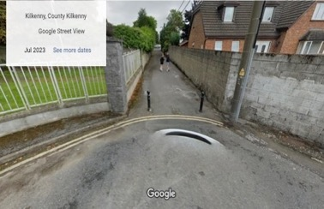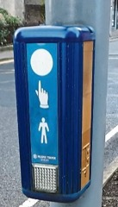

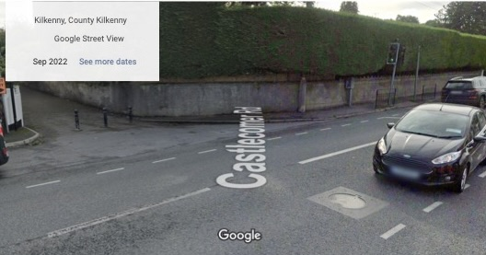
This road is very busy with traffic. Make sure to cross by the Traffic lights, press the button and wait until you see the green light to cross, and it is safe to cross the road. Make sure traffic has stopped.

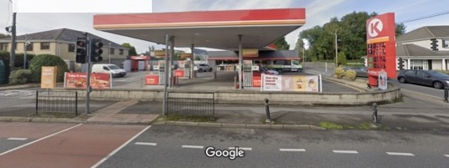
Circle K is across the road. Be careful of any cars driving in or out of the service station. Don’t forget to use the traffic lights on the way back.

Other Important Information

Sometimes your leaders will be busy doing other things, so they may not be immediately available to you. Your workshop assistant will help you , and get in touch with you leader too. You can text or call them, but they may not respond straight away. Just be patient until they can get back to you.

The Nurse.
If you are feeling unwell , and your leaders can’t help you might have to visit the nurse.

Our Nurse is called Emma, and she can help you. One of the Adults will bring you over to visit the nurse and will wait for you until you are finished. Emma will be on site from 9am – 5pm every day.

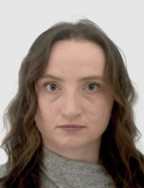
Emma has visited 30 countries before she turned 30, and her favourite musical is Wicked.

Special Events

Monday Evening Activity

On Monday night you will get to visit all the Youth Theatre Ireland team and do some fun activities, This will be an opportunity to meet us and we find out a little bit about you too. Bring ear plugs or ear defenders if you need them.

Tuesday Yellow by Jody O’Neill

‘Yellow’ is a joyous, uplifting piece of theatre written by Jody O’Neill, writer of the
award-winning, ‘What I (Don’t) Know About Autism

It follows the story of Lizzie, a creature of habit, and how her life is irrevocably
changed when she sleeps through her alarm clock and has to break her routine,
with very unexpected consequences. The show is 23 minutes long and then there will a discussion with Rebecca and the actor Eleanor and the director Al. It will about 20 minutes long

For this show we will all be sitting down in the Macadoo building. It will look a bit like this. There will be some noises and some music. You can bring ear plugs or ear defenders for this. If you are too hot or overwhelmed you can leave the space.

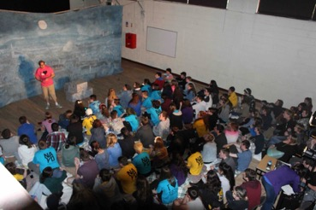
This is Eleanor Walsh, the actor who will be performing the show

Wednesday – the Variety Night

This will be a night where anyone can chose to sing a song or perform a skit. If you don’t want to take part, you don’t have to. It will take place in the boys study hall which will look a bit like this. We will sit down on the chairs and watch the show.

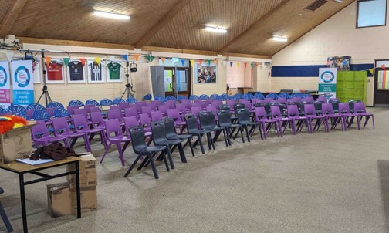

When the show starts, the lights will go down and the room will get darker. It might look a little bit like this 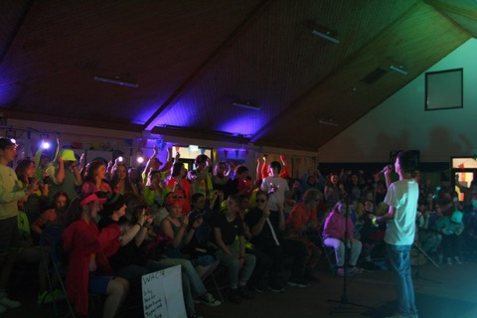
It might get very warm, and it could get loud as people might be singing or clapping. You can wear your ear defender or ear plugs here. You can take a break if you need it and go outside or into the quiet room or your bedroom.

Thursday – BBQ
For dinner on Thursday we will have a special BBQ outside. We will all queue up for or food and you can have burgers, hot dogs and other things. If you don’t ea these you can bring your own food or snacks.

Thursday - NFYT Party Night

The party will happen in the boys Study Hall and around that building.

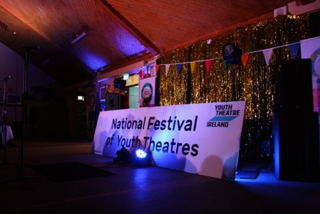
It will look a bit like this. It will be a lot darker than usual and there will be music playing, the music may get loud.

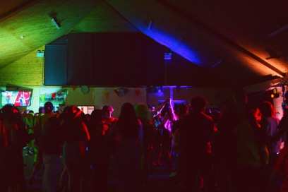
Remember – Just ask for help if you need it. Ask any of the adult leaders for help. If they can’t help you, they will find someone who can.

Don’t be afraid to ask questions or try some new things.

Have Fun and Enjoy yourself.
You might want to wear your ear plug or ear defenders here. If it is too loud you can take a break and go outside or you might want to go to the quiet room or the craft room. You can come back in whenever you like.

TIMETABLE

