DRAMA
FACILITATION
TRAINING COURSE

Name: ___________________

Learner Handbook
Youth Theatre Ireland
Training Programme


Drama Facilitation Training is a Youth Theatre Ireland programme.

Version History

Version | Date | Changes
1.0 | September 2022 | Draft 1
2.0 | October 2023 | 9.2 – Extenuating Circumstances. Pg.11  9.3 How does a learner apply to defer an assessment due to extenuating circumstances? Pg. 12  9.4 Request for Assessment Support. Pg. 12  9.8 Learners Journey to Accreditation – Step by Step. Pg. 13  9.9 Academic Appeals. Pg. 15  13. Protection for Enrolled Learners. Pg. 16
3.0 | February 2024 | 9.9 Academic Appeals Process Updated p11
3.1 | March 2026 | 7. Delivery Methodologies – Assignment weighting updated p 10
3.2 | April 2026 | 6. Updated to better reflect learner journey  7. Delivery Methodologies now include use of Padlet
3.3 | August 2026 | 1.Updated QQI Logo  29.Added Cathal’s details as core-tutor

TABLE OF CONTENTS
INTRODUCTION 4
PROGRAMME DESCRIPTOR 7
1. Programme Profile 7
2. Learner Profile 7
3. Programme Objectives 7
4. Entry Criteria 8
5. Programme Duration 8
6. Delivery Mode 8
7. Delivery Methodologies 8
8. Transfer and Progression 9
9. Assessment 10
9.1 Late submission of assessment 10
9.2 Extenuating Circumstances 11
9.3 How does a learner apply to defer an assessment due to extenuating circumstances? 12
9.4 Request for Assessment Support 12
9.5 Submission of Assessment 13
9.6 Assessment Malpractice 13
9.7 What is Learner Malpractice? 13
9.8 Learners journey to accreditation – Step by step 13
9.9 Academic Appeals 15
10. Planning Assessment 15
11. Grading 16
12. Integration 16
13. Protection for Enrolled Learners 16
DRAMA FACILITATION TRAINING COURSE POLICIES 18
QUALITY ASSURANCE POLICY STATEMENTS 19
ASSESSMENT PROTOCOL AND CODE OF CONDUCT 21
USEFUL LIST OF RESOURCES 21
NFQ 23
COURSE CO-ORDINATORS 24

INTRODUCTION
Youth Theatre Ireland with the support of Creative Ireland, are excited to congratulate and welcome you to the Drama Facilitation Training Course
Youth Theatre Ireland is the national development organisation for youth theatre. We support a network of youth theatres who deliver year-round programmes of drama workshops and performance opportunities to young people aged 12 - 22 from cities, towns and villages across Ireland.
Established in 1980, Youth Theatre Ireland is unique in its commitment to youth-centred drama practice. At Youth Theatre Ireland, we know that youth theatre is a place to develop young artists and young citizens. We promote youth drama opportunities that focus on the artistic, personal and social development of young people.
Youth Theatre Ireland Promotes;
- Drama as a medium for learning and as a means of expression for young people
- The advancement of the artistic, personal and social development of young people through drama and performance related skills
- Youth theatre as a medium to extend and enhance young people’s understanding of theatre as an artform
- The emergence and development of youth theatre in Ireland
We are guided by the following core values:
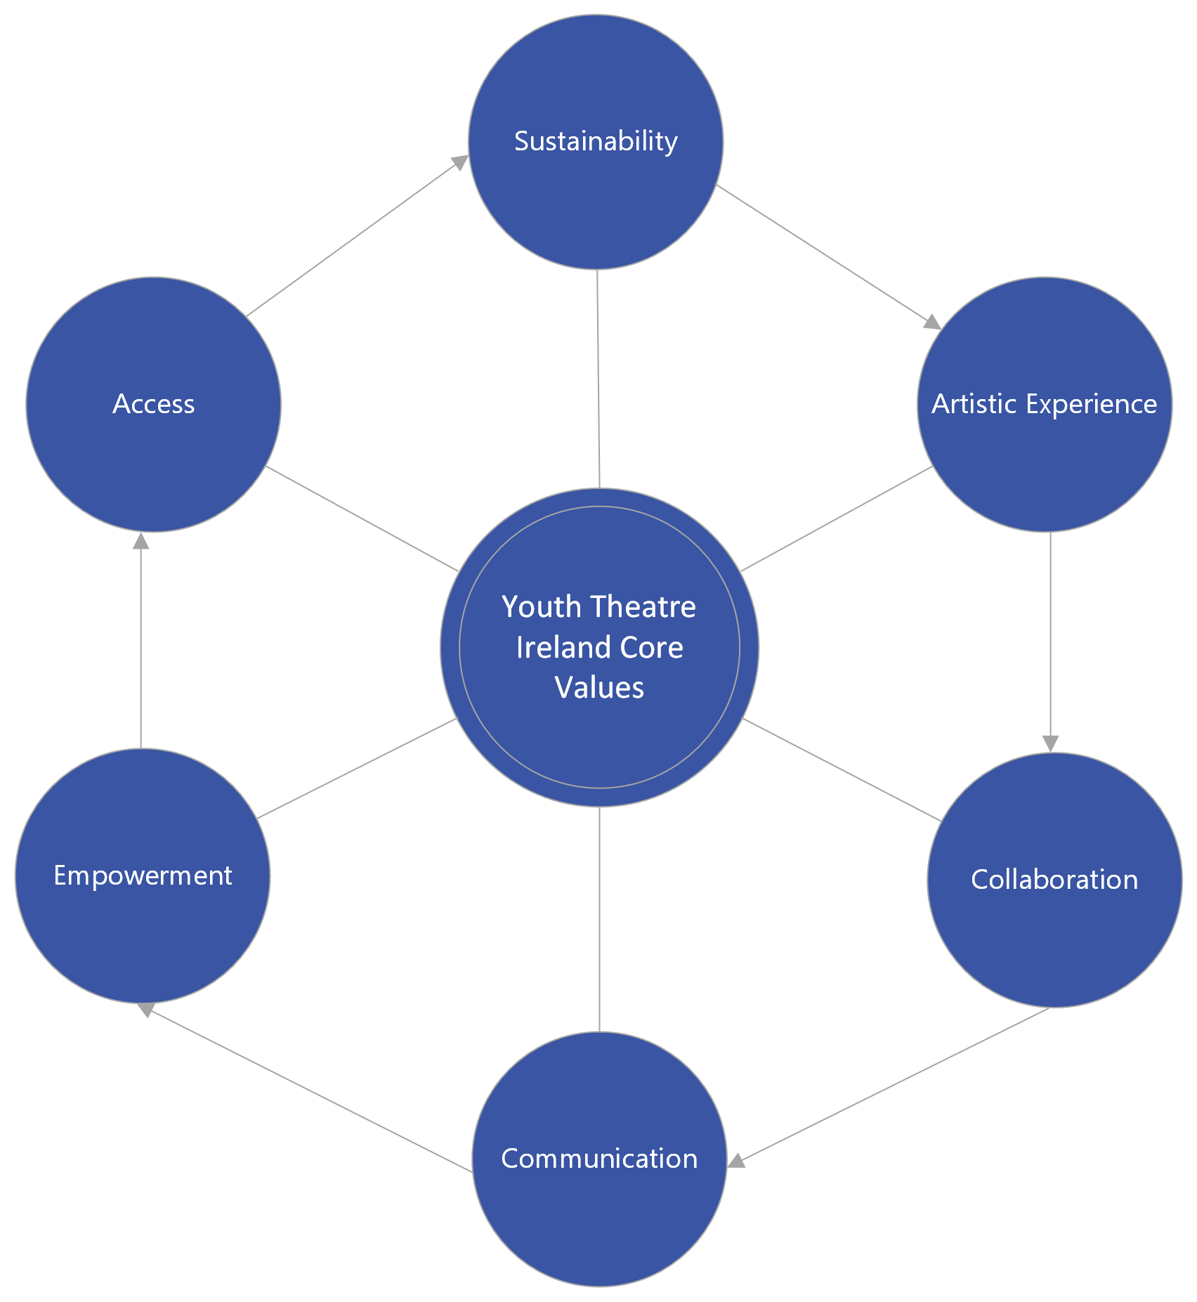
Access
We believe youth theatre should be diverse, inclusive, and accessible to all young people in Ireland.
Sustainability
We believe in sustainable youth theatre practice, that is adaptive and responsive to local needs and that incorporates long term planning as a key goal to success.
Artistic Experience
We believe in every young person’s potential to be a creative artist. We work with and support volunteers, professional practitioners, creators, and producers to support young people to achieve their creative potential and to ensure high quality artistic experiences for all young people in their youth theatre locally and at national programmes.
Empowerment
We believe in the voice and vision of young people. We work to empower young people involved in youth theatre to achieve their full social, personal, and artistic potential by including their voice in our strategic and artistic planning.
Collaboration
We value partnership and collaboration with new and existing partners, funders, and youth theatres to deliver our strategic objectives.
Communication
We are committed to communicating the value of youth theatre practice to all our audiences and stakeholders.

Creative Ireland
Creative Ireland’s Creative Youth programme aims to give every child practical access to tuition, experience and participation in the arts. The plan aims to increase opportunities for activity and participation and to influence public policy around creativity in both formal education and out-of-school settings. It aims to create a place where knowledge and creativity are equal partners in the formation of our young people, giving them an opportunity to become creative, active citizens. This commitment is cognisant of youth theatre as an established youth arts practice that contributes to the support of young people’s mental wellbeing; critical and active citizenship; and the development of imagination and creative thinking.

PROGRAMME DESCRIPTOR

1. Programme Profile
The aim of the programme is to provide training for those who wish to acquire the knowledge, skills and competence required to become a professional drama facilitator. This award will provide learners with opportunities to transfer and progress to programmes leading to higher education and training awards. There are 2 modules in this programme. Upon successful completion of the modules the learner may achieve 30 credits which can then be combined with other components to amass the required 120 credits for a level 6 QQI major award.
The programme is designed to be delivered on a part-time basis. Overall the programme is based on a duration of 300 hours (typical learner effort), to include both directed and self-directed learning.
2. Learner Profile
It is expected learners will be from a variety of social, economic and/or cultural backgrounds. They will have expressed an interest in working as a facilitator through the medium of drama. They may have previous experience in the arts and/or facilitation and wish to enhance their employment opportunities in the sector. They may have gained previous academic qualifications in drama or the arts and wish to gain practical drama facilitation skills.
Learners will demonstrate an ability to work at a QQI level 6 involving detailed theoretical understanding of the course material, an ability to deal with course assignments and an ability to work independently and self-manage.
They will possess good communication skills, an ability to work with other people and participate in group work and display an ability to accept/respond to group and tutor feedback. They will have some degree of relevant arts experience and/or facilitation or they will demonstrate an understanding of the context or the value of the arts.
3. Programme Objectives
To enable learners to
- Facilitate drama workshops that engage people as active participants, by using group or ensemble drama methods.
- Understand the power of individual ownership and personal empowerment within the safe environment of a drama workshop.
- Appreciate, analyse and demonstrate the leadership skills required to facilitate excellence in drama workshops.
- Encourage the development of others by using drama methods that correspond to their developmental needs.
- Actively seek employment in schools, colleges, youth clubs, adult groups, youth reach, youth theatres, groups whose members have a disability, theatre in education drama outreach programmes, theatres and other relevant sectors.
- Demonstrate their ability to communicate to potential employers the methodologies and practice of drama facilitation.
- Understand the methodological implications for construction of their own drama facilitation practices.
- Initiate and organise projects specific to the needs of the participants in a variety of settings.
- Access further relevant education/training
4. Entry Criteria
Learners will demonstrate an ability to work at a QQI level 6 involving detailed theoretical understanding of the course material. Learners should be able to
- Fluently read, draft, prepare and understand complex information that is personally relevant and reflects a broad knowledge base, for example, text and other information relating to abstract theoretical ideas, concerns or procedures
- Fluently read, draft, prepare and understand complex quantitative information
- Solve problems, independently and as part of a range of different groups
- Attend scheduled workshops/lessons throughout the programme
- Complete self- directed hours of learning in the form of practice time, preparation, study time and reflection time, as appropriate
- Participate in all programme related activities
- Participate in work experience, as appropriate
- Demonstrate the use of a broad range of specialised skills and tools
- Work independently and self-manage.
5. Programme Duration
The programme is offered on a part-time basis through the Youth Theatre Ireland Drama Facilitation Training programme. It is expected that the learner may achieve certification in the two modules within one academic year. For some learners a longer duration than one year may be required to achieve the modules in exceptional circumstances.
The programme is based around an overall duration of 300 hours (typical learner effort) to achieve a minimum of 30 credits. This duration includes time for both self- directed learning by the learner and directed learning through scheduled workshops and activities.
6. Delivery Mode
The training is delivered in person utilising practice-led methodologies to best reflect a youth theatre setting. During the second module learners will meet with mentors online as they shape their skills demonstrations. All course material is hosted on our online platform Padlet.
7. Delivery Methodologies
The delivery methodologies have been chosen based on the needs and profile of the learner together with the themes and content of the various programme modules making up this programme. Youth Theatre Ireland follow the highest standard of Universal Design for Learners in how we engage learners, present our work and enable learners to action their response. The following are the appropriate delivery methodologies to be employed in delivering this programme:
- Workshop
- Lecture
- Tutorials
- Presentations / Demonstrations
- Supervised Practice
- Portfolio Development
- Self- directed learning which may include practice time, preparation, study time and reflection
- Practical Work Training
- Discussion Groups / Role Play
- One to One Supported Training
- Peer Learning
- Simulated Work Environment
- Teamwork
- Giving & Receiving Feedback
- Work based training
In person learning is supported with hosting all course material on our online platform Padlet. Youth Theatre Ireland has designed the following programme for learners to achieve certification two level 6 QQI Modules.

Programme Module Title | Compulsory or Optional | Duration in Hours | QQI Component Title, Code and Credit Value | Assessment Technique
Engaging with Drama | Compulsory | 150 hours | Engaging with Drama 6N3545 Credit Value 15 | Skills Demonstration 60%  Learner Record  40%
Leadership | Compulsory | 150 hours | Leadership 6N2191  Credit Value 15 | Skills Demonstration 60%  Learner Record  40%
Total Credits Required for Certification in the Major Award 120 Credits
8. Transfer and Progression
The learner who successfully completes this programme will achieve the Level 6 QQI qualification in the following modules: Engaging with Drama 6N3545 and Leadership 6N2191. The learner may then be eligible to combine the credit from these modules to other components and build a full Level 6 award and be apply to progress to the next or higher levels of the National Framework of Qualifications (NFQ) with a higher education provider.
9. Assessment
All assessment activity will be conducted in line with Youth Theatre Ireland’s Drama Facilitation Training quality assurance policy Fair and Consistent Assessment Learners and all associated procedures, including QQI quality assuring assessment procedures.
In the majority of cases the tutor will take on the role of assessor when it comes to marking and grading the learner’s work for certification purposes. There is specific information relating to assessment in each of the Programme Modules which must be adhered to, including:
- The assessment technique to be used to assess the learner
- The weighting for each piece of assessment
- The time allocated to allow the learner complete the assessment, as appropriate to the assessment technique
- The format and context in which assessment is administered
- The assessment criteria to be used by the assessor when marking and grading the assessment evidence marking sheets
The learner will complete an assessment portfolio. Evidence included in the portfolio will be accompanied by an assessment instrument such as an assessment brief, as appropriate to the assessment technique. The assessment instrument outlines the set of instructions given by the assessor to the learner in order to guide the learner in completing the assessment task(s).
Each learning outcome will be evidenced in the portfolio of assessment. In order to avoid over-assessment, it is only necessary to evidence achievement of each learning outcome once, as appropriate. Integrated assessment is encouraged. The learner will be assessed to measure attainment of particular learning outcomes for certification purposes once s/he has had an opportunity to learn and consider the relevant programme module content associated with those learning outcomes. Assessment will be scheduled into the delivery of this programme at appropriate intervals.
Class work will not be included in the portfolio of assessment for certification purposes. The learner may produce a portfolio of class work for their own use but this should not be considered when marking and grading the learner’s assessment work.
The learner who does not complete the whole programme but who does demonstrate the standard for one or more components may achieve a Component Certificate.
9.1 Late submission of assessment
Youth Theatre Ireland operates a strict deadline policy for the submission of assessment material unless there are proven extenuating circumstances. However, in order to give a chance to learners who have missed a deadline and do not have proven extenuating circumstances, Youth Theatre Ireland will facilitate late submission up to two weeks after the due date. In order to be fair to learners who submit on time penalties are imposed for late submission of assessments at levels 4, 5 and 6 as follows:

Lateness | Penalty | Instruction for assessor
Up to 7 calendar days late | 10% | Multiply total mark achieved by learner by 90%
8 – 14 calendar days late | 20% | Multiply total mark achieved by learner by 80%
Assessments submitted more than 14 days after the deadline will not be accepted unless there are proven extenuating circumstances.
Assessors should record any penalties imposed on the marking sheet. Learners need to be informed of YTI’s procedure regarding deadlines and applying for an extension, deferral or repeat of an assessment activity due to extenuating circumstances.

9.2 Extenuating Circumstances
What if I have a valid reason for submitting an assessment late?
If there is a valid reason for submitting an assessment late, learners can apply to defer an assessment or get an extension to a deadline due to extenuating circumstances. Please contact the course tutors if you require an application to defer assessment.
What are extenuating circumstances?
Extenuating circumstances are exceptional circumstances that temporarily prevent a learner from completing or seriously impair their performance in an assessment activity. The extenuating circumstances must be:
1. Unexpected
2. Beyond the learner’s control
3. Have a significant impact on an assessment performance
A serious illness or a family bereavement could be considered as extenuating circumstances, but a minor illness or examination nerves would not be considered extenuating circumstances in relation to assessment.

9.3 How does a learner apply to defer an assessment due to extenuating circumstances?
If a learner wants to apply for an extension to a deadline for an assignment, project, portfolio or learner record or to defer an examination or skills demonstration the learner needs to complete a YTI application form This form should be submitted to your Course Coordinator no later than 2 weeks after the date of the assessment activity.
The learner should provide enough information on their application to allow the coordinator to make a fair decision and should be supported with written evidence e.g., a medical certificate.
The information on this form will be dealt with in the strictest confidence and Youth Theatre Ireland Staff will not disclose information in any way beyond what is required to deal with this application.

9.4 Request for Assessment Support
Youth theatre Ireland aims to do all that is reasonable to provide accommodation in examinations and skills demonstrations to enable learners with specific learning needs to demonstrate their level of actual attainment, in as far as is possible, without undermining the validity of the assessment. Please contact the course tutors if you require an application for Request for Assessment Support.
Request for Assessment Supports can be made on the following five grounds:
1) Learning Difficulty
2) Hearing Difficulty
3) Visual Difficulty
4) Physical Difficulty
5) Mental Health or Behavioural Difficulty
The accommodations available depend on the specific disability or learning need. They may include the following:
- Using a word processor or a recording device
- Assistive technology
- A scribe in exceptional cases
- A reader
- A colour identifier
- A waiver from spelling, grammar and punctuation in language subjects
- Additional time
- Enlarged papers

9.5 Submission of Assessment
When submitting assessments learners need to put a cover page on their learner records, essays and projects. They must put their name the title of the assessment, the Module number and the submission date.

9.6 Assessment Malpractice
Everyone involved in assessment, from design to implementation, has a responsibility for ensuring the integrity and validity of YTI Assessment Procedures.
An assessment malpractice is any act or practice, which brings into question the validity, or integrity of the assessment process and which normally arises due to one or more non-accidental factors.
It is the assessor’s responsibility to check the reliability of learner evidence where there is a suspicion of learner malpractice. The assessor or examinations supervisor is responsible for ensuring that any instances of assessment malpractice are reported in accordance with these procedures.
Additionally, all staff involved in the assessment process must ensure that the assessment process is conducted in line with quality assurance policies and procedures and that any variances in assessment practices are investigated appropriately as outlined in this procedure.

9.7 What is Learner Malpractice?
Learner Malpractice is defined as malpractice committed by a learner during the course of the assessment process. Examples of learner malpractice include but are not limited to: (1) Plagiarism and (2) Inappropriate Behavior.

9.8 Learners journey to accreditation – Step by step
Step 1: Planning + devising Assessment
- Define the learning outcomes that the assessment will measure.
- Identify the types of assessments that will be used.
- Develop the assessment criteria and procedures.
- Pilot the assessment to ensure that it is clear, fair, and reliable.
- Pending successful approval of assessment by YTI board, the assessment will be
Implemented into the course programme.
- Responsibility: Training Programme Manager and National Training Coordinator in consultation with the Education Committee and the Staff Training Committee.
Step 2: Communication and Administration of Assessment
- Provide the learners with information about the assessment criteria, the types of assessments that will be used, and the timing and location of the assessments.
- Answer any questions that the learners may have about the assessment.
- Make arrangements for the learners to take the assessment.
- Responsibility: Training Programme Manager and National Training Co-ordinator and the trainers and assessors.

Step 3: Conduct Assessment
- The learners take the assessment in the agreed upon way.
- The trainers or assessors monitor the assessment to ensure that it is conducted fairly.
- Responsibility: Learners, Trainers and assessors.

Step 4: Marking of Assessment
- The assessments are graded by the trainers, assessors, or an external body.
- The grading is done according to the assessment criteria.
- The learners are given feedback on their performance.
- Responsibility: Training Programme Manager and National Training Co-ordinator

Step 5: Communication of Provisional Result
- Learners are given a provisional result
- The appeals process is implemented if needed

- Responsibility: Training Programme Manager and National Training Co-ordinator

Step 5.5: Appeals Process
- Please see Youth Theatre Irelands Appeal Process Policy for details
Step 6: Internal Verification
- A panel of experts reviews the assessments to ensure that they have been graded fairly.
- The panel of experts may make recommendations for changes to the grading.
- Responsibility: Training Programme Manager and National Training Co-ordinator

Step 7: External Authentication
- The results of the assessment are verified by an independent expert, the External Examiner.
- The External Examiner ensures that the assessment process has been followed correctly.

- Responsibility: External Examiner.

Step 8: Ratification of Results
- The results of the assessment are approved by the Results Approval Panel.
- The approval process ensures that the results are fair and accurate.
- Responsibility: Results Approval Panel.

Step 9: Communication of Results
- The learners are informed of their results in writing, verbally, or through an online portal.
- The learners are given an opportunity to appeal their results if they are not satisfied.

- Responsibility: Training Programme Manager

Step 10: Appeals Process
- The appeals process is governed by the Youth Theatre Ireland Results Approval Panel and the Training Programme Manager.
- The appeals process ensures that the learners have a fair opportunity to challenge their results.
- Responsibility: Results Approval Panel and the Training Programme Manager.

Step 11: QQI Certification
- The learners are awarded a QQI qualification if they have successfully completed the assessment.
- The QQI Board ensures that the qualifications are of a high standard.
- Responsibility: QQI

Step 12: Communication of Final Result
- Learners are given a provisional result

- Responsibility: Training Programme Manager and National Training Co-ordinator.

9.9 Academic Appeals
9.9.1.Introduction
The appeals process is designed to provide learners with a fair opportunity to challenge their assessment results if they believe there has been a mistake, inconsistency, or unfairness in the evaluation process. The process is governed by the Youth Theatre Ireland’s Results Approval Panel and the Training Programme Manager. The following steps outline the appeals process:

9.9.2. Initiating an Appeal:
- Learners who wish to appeal their assessment results must submit a written appeal to the Training Programme Manager within 5 working days of receiving their results.
- The appeal should clearly state the reasons for disputing the results and provide any supporting evidence.

9.9.3. Receipt of Appeal:
- Upon receiving the appeal, the Training Programme Manager acknowledges the receipt of the appeal in writing within a reasonable timespan (no more than 20 working days.)
- The appeal is then forwarded to the Results Approval Panel for review.

9.9.4. Review by Results Approval Panel:
- The Results Approval Panel, consisting of qualified individuals not directly involved in the initial assessment, reviews the appeal.
- The Panel considers the appeal, assessment materials, relevant documentation, and any additional evidence presented by the learner.
- The Panel aims to reach a decision within 5 working days from the receipt of the appeal.

9.9.5. Appeal Decision:
- The Results Approval Panel makes a decision based on the merits of the appeal and the evidence presented.
- The decision may result in upholding the original result, adjusting the result, or ordering a re-evaluation of the assessment.
- The decision is communicated in writing to the learner by the Training Programme Manager within 5 working days

9.9.6. Implementation of Decision:
- If the decision requires a re-evaluation of the assessment, this process is carried out by an independent assessor who was not involved in the initial evaluation.
- If the decision leads to an adjusted result, the new result is communicated to the learner.

9.9.7. Final Decision:
- The decision reached by the Results Approval Panel is considered final and binding.

9.9.8. Communication of Final Decision:
- The final decision is communicated in writing to the learner by the Training Programme Manager within 5 working days.
- The communication includes a clear explanation of the decision and the rationale behind it.

9.9.9. Resolution of Outcome:
- Depending on the final decision, appropriate actions are taken to update records, notify relevant parties, and issue corrected documentation.

The appeals process ensures that learners have a legitimate avenue to challenge their assessment results and seek resolution. The Results Approval Panel and Training Programme Manager are responsible for overseeing the fairness and integrity of the appeals process, providing learners with a transparent and equitable opportunity for recourse.

10. Planning Assessment
All procedures in Youth Theatre Ireland’s Drama Facilitation Training Quality Assurance will be adhered to in relation to the planning of assessment. An assessment plan will be devised for the programme that will contain a timetable for all assessment activities.

11. Grading
Distinction: 80% - 100%
Merit: 65% -79%
Pass: 50% - 64%
Unsuccessful: 0% - 49%

12. Integration
Opportunities to integrate delivery and assessment across programme modules may be identified and this is encouraged.
Where overlap is identified between the content of two programme modules, the tutor may integrate the delivery of this.
Integration may also be used where there is an opportunity for the learner to produce one piece of assessment evidence that demonstrates learning outcomes from more than one programme module. This means the learner will produce fewer pieces of assessment while still demonstrating the required standard for all the learning outcomes included in the programme.
It is important that the assessment evidence produced as a result of an integrated assessment is assessed in line with the separate criteria for each relevant programme module and documented and recorded

13. Protection for Enrolled Learners
In the unlikely event that Youth Theatre Ireland is no longer in a position to offer an accredited programme to enrolled students, arrangements are in place to provide financial cover to those who have already paid tuition fees.
Youth Theatre Ireland has learner protection arrangements in place with respect to enrolled learners on all QQI validated courses, in accordance with the Qualifications and Quality Assurance(Education and Training) Act 2012.
In the event that Youth Theatre Ireland ceases to provide a programme for any reason, a full or partial refund of fees will be preferred to affected participants. This is by way of a financial bonding agreement. The refund amount will depend on the unused portion of the fees paid.
Specific details with regards to timelines, refunds are outlined in the relevant Protection for enrolled Learners insurance policy, put in place at the beginning of all QQI accredited courses.
All QQI accredited programmes of education and training of 3 months or longer duration are covered by arrangements under section 65 (4) of the Qualifications and Quality Assurance (Education and Training) Act 2012.
Youth Theatre Ireland operates the following policies for all qualifications from awarding bodies, including QQI programmes, in cases where a programme may or may not run:

A: Non-commencement of an offered programme
It can happen that a programme was offered but will not run for reasons such as non-viable numbers, unsuitability of location or unavailability of appropriate teaching staff. In such cases, learners are offered the following:
Full refund of fees paid for that academic year and appropriate guidance as to other education options.
In such cases, the decision to not run a programme is made no later than 5 working days prior to the proposed start date for programmes at levels 5-6 of the National Qualifications Framework (NFQ). Refunds are made to those persons or organisations that originally paid the programme tuition fee.
Youth Theatre Ireland notifies prospective learners, in all correspondence and publications, that programmes may not commence for reasons such as those outlined above.
B: Cessation of a programme that has commenced
In exceptional cases, a programme may be terminated after it has commenced but before the normal completion date. Reasons can include non-viable numbers, unsuitability of location or unavailability of appropriate teaching staff. In such cases, learners will be offered the following options
Full or partial refund of fees paid for that academic year and appropriate guidance as to other education options.
Where appropriate, certification will be provided for successful completion of modules.
Refunds are made to those persons or organisations that originally paid the fee.

DRAMA FACILITATION TRAINING COURSE POLICIES
This Learner Handbook has been designed to provide you with both an overview of the training course, which you will follow, and as a reference guide containing useful information. It will be supplemented by other material provided throughout the course.
David Kelly & Barry Morgan are the Course Co-ordinators. Youth Theatre Ireland’s Drama Facilitation Training runs during weekend residentials. There will also be a number of Masterclasses with professional facilitators in order to give participants as wide and varied an experience as possible. Times may vary throughout the year depending on training opportunities and needs. Time changes will be given as far in advance as possible. Schedule updates will be given on a regular basis as required.
Procedures for late arrivals and absences
All requests for time off must be delivered ahead of time to the course co-ordinators. If prior notice is not possible i.e. sickness on day, family emergency or unforeseen lateness contact the Youth Theatre Ireland Mobile number on 086 829 5851 or the Youth Theatre Ireland office 018781301.
Disciplinary procedures
If procedures for late arrival and absences are not adhered to or regular late coming or absences persist then the co-ordinators reserve the right to issue verbal / written warnings. The issuing of warnings is down to the judgment of the co-ordinators. Participants will be dismissed in cases where verbal and written warnings have been issued and unprofessional conduct persists.
Plagiarism
Participants will submit work in good faith and sign their name to verify that the work is their own. However in cases where the course co-ordinators suspect plagiarism participants may be asked to produce evidence of reading & research. It will then be at the discretion of the co-ordinators whether to accept the work in question. The work you submit must also be your own, unless otherwise directed by your coordinator. If you collude with other participants to prepare work jointly or copy each other’s work it is unacceptable.
Deadlines
Deadlines for submission of work will be set at the time the assignment briefs are issued. Extensions to deadlines must be approved by course co-ordinators and must be negotiated in advance of deadline. Each case will be considered individually. Failure to submit work on time will result in loss of marks or failure of assignment. Participants are responsible for keeping records of their own work and previously submitted work must be reproduced for end of year assessment.

QUALITY ASSURANCE POLICY STATEMENTS
Communications Policy
It is the policy of Youth Theatre Ireland that there exists an efficient and working method of communication between learners, staff and other stakeholders or those with an interest in the work we do.
We believe that good communication is essential to the smooth running of a well- organised and proficient training programme. Therefore, we commit to providing all the necessary information regarding the programme on offer and to implement a system of evaluation for all parties involved to ensure our programme is as relevant and useful to our learners and other stakeholders.
Equality Policy
As a national organisation we create a context and programme that places the equality of the young person and the relationships with those they work with at the core of our work. Youth Theatre Ireland commit themselves to Equality of Opportunity and to eliminate discrimination as defined under the terms of the current legislation: The Employment Equality Act 1998 and the Equal Status Act 2000. All staff are informed of our policy and equality is addressed in our staff inductions and development programmes.
Staff Recruitment and Development
Youth Theatre Ireland are committed to providing an open and communicative style to employee management. We aim to provide strong leadership, the best conditions we can and a flexible working environment to help employees attain job satisfaction. Recruitment of staff will be made from the widest possible field, and by public advertisement. Recruitment and selection will always reflect our commitment to equality of opportunity; all advertisements will make reference to this commitment. Further training and development for staff is actively encouraged and all efforts are made to accommodate and facilitate this.
Access, Transfer and Progression
Youth Theatre Ireland will ensure that all procedures are in place to facilitate, in as much as we can, a learner’s entry and successful participation in our programme. We will ensure that all potential learners can make informed choices regarding the programme and that there will be no unnecessary barriers to entering the programme and in having their previous learning recognised. We will also enable learners to transfer or progress to other programmes within the National Framework of Qualifications.
Programme Development, Delivery and Review
It is the aim of Youth Theatre Ireland to provide training for people in the art of facilitation and youth arts and to develop an understanding of good youth drama practice. We aim to offer participants a wide range of workshop styles, themes, structures and strategies and provide them with an understanding of the theory behind drama facilitation methodologies and practice.
Fair and Consistent Assessment of Learners
It is our policy that all learners are assessed fairly and that this assessment is consistent with established standards of practice and in accordance with QQI regulations. We believe that all reasonable accommodation be made to cater to learners needs and that the learners should have all the information necessary to successfully participate in assessment.
Self-Evaluation of Programmes and Policy
Youth Theatre Ireland recognises the importance of reflection on the effectiveness of our services and firmly believe that self-evaluation is a fundamental part of a successful programme. Therefore we are committed to evaluating our programme on a regular basis including input from learners, staff, stakeholders and independent sources.

ASSESSMENT PROTOCOL AND CODE OF CONDUCT
As a learner with Youth Theatre Ireland, I can expect the following in relation to assessment:
- Fair and consistent assessments that are transparent and accessible.
- A valid, reliable, quality assured assessment process
- Accurate, accessible information about course requirements, learning outcomes and assessment dates
- Clear instructions in relation to assessments that provide opportunities to demonstrate achievement of the standards of knowledge, skills and competencies required
- Information regarding assessment procedures in a learner handbook
- An assessment process that is internally verified as fair and consistent
- Externally authenticated assessments consistent with national standards
- Reasonable and appropriate accommodations in assessments
- Constructive feedback from my Tutor/assessor
- Security of all assessment materials submitted
- A right to appeal results and to repeat assessments under
- Where learners have complaints, they are expected, in the first instance, to address it with the person concerned. If still unsatisfied, they may take their concerns to the course coordinator, and thereafter may appeal to the National Director within Youth Theatre Ireland.
As a learner with Youth theatre Ireland:
- I will attend and participate in all online in person workshops and classes as required
- I will submit assessments on time and in the format requested
- I will bring my support needs to the attention of the YTI Co-ordinators in a timely manner
- I will prepare for and participate fully in assessment
- I will take responsibility for ensuring that I have received all assessment information
- I will familiarise myself with and adhere to Youth Theatre Irelands Assessment Procedures and regulations
- I will arrive on time for skills Demonstrations
- I will submit my own original work, correctly reference any quotations, and not plagiarise anyone’s work
- I will attend feedback sessions and request additional feedback if required
- I will keep copies of all my assessment materials where possible
- I will review my progress to get the most from my participation on the course.

USEFUL LIST OF RESOURCES
Web Resources:
- www.youththeatre.ie
- www.creativedrama.com
- www.teachingonline.org/drama2.html
Books:
- Laying the Foundations by Dave Kelly published by NAYD.
Authored by NAYD's National Training Coordinator, Dave Kelly, this book has been written for all drama facilitators, trainee drama facilitators, new youth theatre leaders, senior youth theatre members, teachers and youth workers who want to develop their drama facilitation skills.
- Playing the Game by Christine Poulter Mac Millan ISBN 978-0-333-40385-3. This is a must have guide for any person wishing to use drama games in their work. It is an easy accessible user-friendly guide for playing games.
- 101 Drama Games & Activities by David Farmer published by Lulu ISBN 978 -1-84753- 841-3. 101. Highly effective drama games and activities, suitable for children or adults
- Drama Themes by Larry Swartz
published by Heineman ISBN-13: 9780435086909. Features all-new games and activities along with practical ideas for assessment and literature links. The teacher- friendly format of this valuable resource will make drama entertaining, educational, and informative.
- Theatre Games by Clive Barker Methuen drama ISBN 9781-1-4081-2519-9. An excellent guide to the theory behind theatre games. The book also includes a DVD – Rom showing the author facilitates some of his excellent theatre games.
- The Drama Ideas Bank by Mary Brooks published by user Friendly Resources. A selection of ideas for improvisation and mime.
- Drama Games for Those Who Like to Say No by Chris Johnston. Publisher Nick Hern Books. ISBN 9781848420496. Particularly aimed at those working with young people and adults in so-called "difficult" groups.
- House of Games by Chris Johnston
- Theatre Games: a new Approach to Drama Training
- Impro by Keith Johnstone
- Improvisation for Theatre (drama and performance studies) by Viola Spolin Theatre Games for the
- Classroom: A Teacher’s Handbook by Viola Spolin Games for Actors and Non-Actors by Augusto Boal
- Structuring Drama Work by Jonathan Neelands
- Drama as a Learning Medium by Dorothy Heathcote
- Structure and Spontaneity: The Process Drama of Cecily O’ Neil

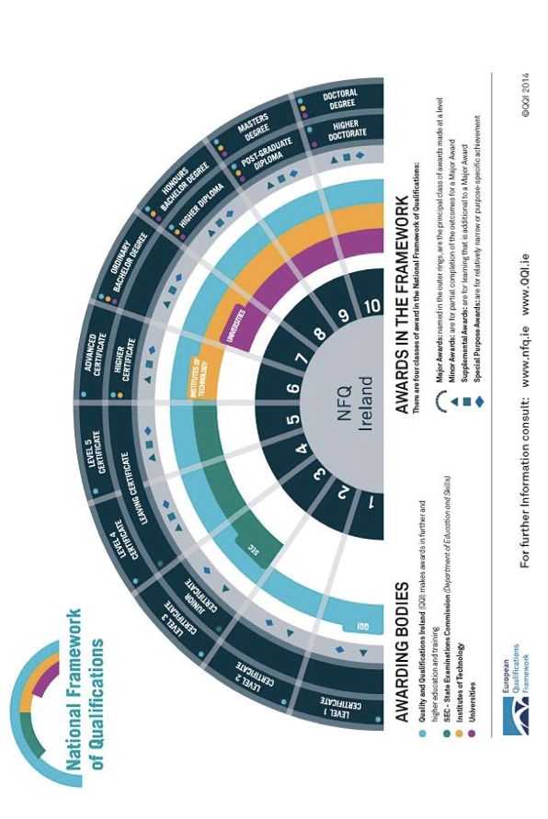
NFQ
The Drama Facilitation Training Course, offered by [Institution Name], has received accreditation from Quality and Qualifications Ireland (QQI), the national agency responsible for the quality assurance of education and training services in Ireland. QQI is entrusted with ensuring that education and training programs meet established quality standards and are aligned with the National Framework of Qualifications (NFQ).

The NFQ is a framework used in Ireland to describe the levels of education and training in a consistent way. It encompasses a wide range of qualifications, from initial education and training to the most advanced academic and professional awards. The framework consists of ten levels, each representing a different stage of learning, from basic skills to the highest level of academic and professional achievement.

The Drama Facilitation Training Course has been evaluated by QQI and has met the rigorous criteria required for accreditation. As a Level 6 qualification on the NFQ, this course is positioned at an intermediate level. Level 6 qualifications are designed for learners who have a good knowledge and understanding of a specific area and can apply skills in various contexts.

In order to achieve QQI accreditation at Level 6, the Drama Facilitation Training Course has demonstrated that it provides learners with a comprehensive understanding of drama facilitation techniques, including theoretical knowledge and practical skills. Participants in this course would have engaged in in-depth study and practical application of drama facilitation methods, enabling them to effectively lead drama workshops, theatre productions, and related activities.

By successfully completing the Drama Facilitation Training Course, participants receive a QQI-accredited Level 6 qualification. This accreditation not only validates the quality and standard of the course but also ensures that individuals who complete the training have attained a nationally recognized qualification, enhanced their employability and opened up opportunities for further education and career advancement.

In summary, the Drama Facilitation Training Course's QQI accreditation at Level 6 on the National Framework of Qualifications signifies its alignment with national standards, ensuring that participants receive a high-quality education in drama facilitation and enabling them to contribute meaningfully to the field of youth arts, performing arts and education.

COURSE CO-ORDINATORS

Dave Kelly – National Training Co-ordinator
Dave has worked with Youth Theatre Ireland (formerly known as The National Association of Youth Drama - NAYD) for twenty three years. He develops, coordinates, and facilitates YTI’s National Training Programme. He is the author of Laying the Foundations: A Guide to Youth Drama Facilitation. Dave was a Co-ordinator and Tutor on Artstrain Youth Theatre Irelands QQI level six fulltime drama facilitation training course from 1999 to 2017. He has a diploma in Arts, Drama and Theatre Studies from N.U.I Maynooth. He is a former member of Dublin Youth Theatre. In 2005 he was Assistant Director on “Dreamtime” the 2005 European Children’s Theatre Encounter hosted by NAYD in Cork and co-directed “Kaleidoscope” a devised piece for the NAYD 25th birthday celebrations. He has been Assistant Director for the National Youth Theatre on four occasions, “The Old Lady Say’s No” (2001) at The Samuel Beckett Centre, “The Caucasian Chalk Circle” (2007), “A Midsummer Night’s Dream” (2008) and “The Seagull” (2009) all at the Peacock. In 2013.
Other work includes: working as a member of the Leargas Trainers Pool facilitating workshops on many of their
programmes. He was the Artistic Director of Dublin Youth Theatre From 2014 to 2021. He has developed drama resources for the Irish Wheel Chair Association and for the G.A.A. He facilitates workshops for the National Youth Council of Ireland. He works as a Mentor and Facilitator: For the Reel Youth Film Project working with various youth groups from Dublin. Facilitating integration workshops and mentoring the young people to devise and shoot their short films. As a Writer and Facilitator: for the Dublin Culture Connects Project working with the young people from the John Bosco Youth Project. Facilitating devising workshops to Write the short film FLIP! screened at the National Concert Hall. A Facilitator For the Dublin City Council and CDYSB Film First Project. Working with young people from various youth projects from Dublin, screen writer Malcolm Campbell (What Richard Did) and Director Colin Thornton (A Date for Mad Mary). To create the short film “Messers” Screened at the IFI Dublin. Dave was a member of the Freelance Artistic Team with the Abbey Theatre Outreach Department for a number of years. He worked on many projects including their drama in the classroom programme, the Abbey Inside Out programmes and Theatre as a Resource programmes. As a facilitator he worked for Dublin City University Access Service orientation programme working with new students each year. From 2004-08. He worked as an advisor and as a lead facilitator for Calipo Theatre and Picture Company on their "Sharp Focus" Cross boarder project. Culminating in the production of five short films. He was a Facilitator/Director at the National Festival of Youth Theatres on three occasions and the Ulster Association for Youth Drama's Millennium Festival. He directed "The Devil in Drag" by Dario Fo for Red Lemon Youth Theatre as part of the B.T. Royal National Theatre Connections Festival. Other work includes the Barretstown Gang Camp, (therapeutic recreation for seriously ill children), Team Theatre Educational Co. on their S.S.D.A Workshop Programme, Graffiti Theatre Company Cork on their primary and secondary school tours and also their New York University Study Abroad Programme in Educational Theatre. He was Arts Council Artist in Residence with Blanchardstown Youth Theatre where he directed a short film "The Lift". International work includes working with the Liege Comtoise D' Improvisation (Besancon France) Facilitator and performer in "D'iGouk", facilitator/director at the 8th Children's European Youth Theatre Encounter (Hanover, Germany) and facilitator/director for Youth for Europe International Exchange (Moscow, Russia).
Barry Morgan – Special Projects Officer
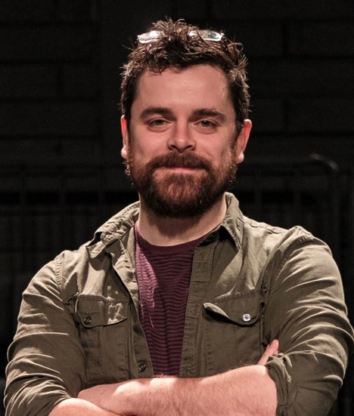
Barry has been working with Youth theatre Ireland as their Special Project Officer for the since 2019. His role supports the development of new Youth Theatres nationwide. His work also includes managing, co-ordinating and teaching on YTI’s part time level 6 six QQI accredited, Drama Facilitation Training Programme. Barry previously designed and co-ordinates ARTiculate, Youth Theatre Ireland’s young writers programme. In 2018 he was Assistant Director of the National Youth Theatre production of “Ask Too Much Of Me”.
Barry is from Drogheda, Co. Louth and was member of Droichead Youth Theatre, he studied Drama Performance in TU Dublin (formally DIT). He is also a graduate of the ArtsTrain drama facilitation training programme.
Barry is one-half of Tailtiu Theatre whose focus is on creating socially engaged interactive theatre for younger audiences. He is also co-founder of Impact Youth Theatre, the only youth theatre operating inside a Direct Provision centre. Barry was Artistic Director of the Dé Luain Players, a theatre group for adults with Down Syndrome, from 2014 - 2020
At the core of all of Barry’s work is the mantra “Tell me and I will forget. Show me and I may remember. Involve
me and I will understand.”
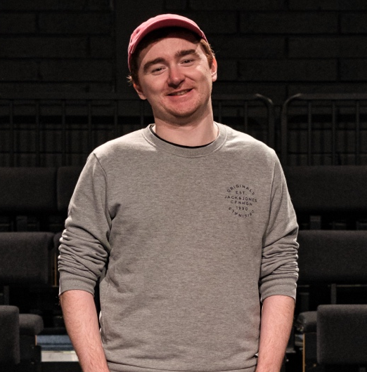
Cathal Thornton – Child Protection and Wellbeing Officer
As Child Protection and Wellbeing officer, Cathal supports member groups with Grda Vetting, policy writing, and helping ensure youth theatre is a safe space for young people. He delivers Child Protection Awareness Programme Training through the NYCI CPAP programme, and also runs the SOUNDBOARD programme,a consultancy group made up of Youth Theatre Paricipants aged 16+
Cathal is from Drogheda, where he was a member of Droichead Youth Theatre. Since then, he has worked as a freelance Youth Arts practitioner with various youth theatres,youth work groups, and art centres. He is the other half of Tailtiu Theatre alongisde Barry, and a frequent collaborator with NYCI’s Youth Arts Programme.

Cathal’s recent projects include The Ripple Effect with NYCI, The Mysteries of Lake Muckno with Iontas Castleblayney and DkIT, and Dear Drogheda with Droichead Youth Theatre. Cathal has a passion for role playing games and brings this expertise to his work, and is interested in using process drama and ‘leader-in-role' techniques to help young people explore texts.

