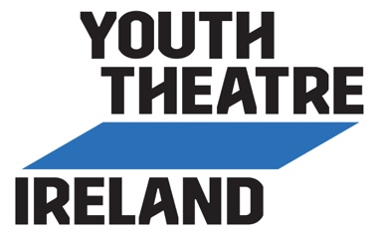
Resources For Youth Theatres
Sample: COVID-19 Declaration Form (Leader)

[Insert Youth Theatre’s Logo]

COVID-19 DECLARATION FORM
For Youth Theatre Leaders

This Covid-19 Declaration Form is part of our Response Plan to help reduce the spread of Covid-19. In the week prior to returning to youth theatre activities, please read and answer the following questions.

If the answer is Yes to any of the questions numbered 1 to 5, you are advised to seek medical advice and complete any required period of self-isolation before you participate in youth theatre activities.

If your status changes after you submit this form, please inform the youth theatre at [Insert Email Address] or call [Insert Mobile Number].

Youth Theatre Leader:

 | YES  P | NO  P
- Do you have symptoms of cough, fever, high temperature, sore throat, runny nose, breathlessness or flu like symptoms now or in the past 14 days?
- Have you been diagnosed with confirmed or suspected COVID-19 infection in the last 14 days?
- Are you a close contact of a person who is a confirmed or suspected case of COVID-19 in the past 14 days (i.e., less than 2 metres for more than 15 minutes accumulative in 1 day)?
- Have you been advised by a doctor to self-isolate at this time?
- Have you been advised by a doctor to cocoon at this time?
If yes, please contact the youth theatre to discuss your engagement in youth theatre activities.
- Have you been advised by a doctor that you are in an at-risk group?
If yes, please liaise with your doctor and the youth theatre regarding your safe participation.

I confirm, to the best of my knowledge, that I have no symptoms of COVID-19, am not self-isolating or awaiting results of a COVID-19 test.

Signature: ____________________________________ Date: ________________

Please email to [Insert Email Address] by [Insert Date].

Please note: [Insert Youth Theatre] is collecting this sensitive personal data for the purposes of maintaining safety at our activities due to the COVID-19 pandemic. The legal basis for collecting this data is based on vital public health interests and maintaining occupational health. The COVID-19 Declaration Form will be deleted immediately once it has been assessed by youth theatre leaders, has been recorded as being received and any necessary follow-up action has been taken.

